ServiceNow Training Manual

Creating interactions

From a Participant Record scroll down to the bottom and find the 5 tabs labeled:

-Coapplicants

-Interactions

-Documents

-Former Names

-Address Histories

Make sure that you have the “Interactions” tab selected and click on the blue “New” button within the tab

This will open the following blank record

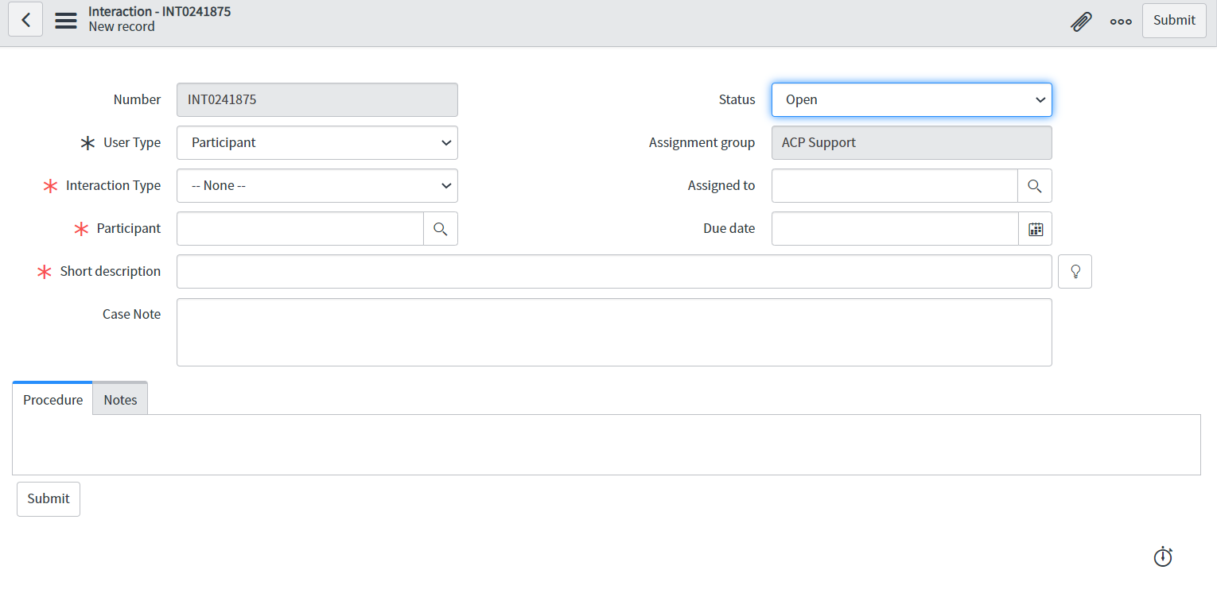

The “Number” and “Assignment Group” will always be auto filled and cannot be altered.

It is on the ServiceNow user to input the following mandatory fields with the correlated information:

-User Type: Participant, Coapplicant, or Application Assistant

-Interaction Type: options will vary depending on the parent record type, but the ServiceNow user must select a type that either matches or aligns the closest with the interaction being input

-Participant: this field name may change, but it will always be filled with the identifying name for the parent record the interaction is referencing

-Short description: brief summary of the interaction, someone scrolling the Interactions List should be able to identify the interaction type and initial actions required based on the short description

The remaining fields are not required, for every interactions:

-Status: Open, Work in Progress, Closed Complete, Closed Incomplete, Pending

-Assigned to: ServiceNow user’s name, or coworker whom you are assigning the interaction to

-Due date: if the interaction will require follow up on a later date, it can be set using this field; cannot be typed in, must be selected from the calendar button on the right of the field

-Case Note: an in depth summary and explanation of the interaction. Should be written in 3rd person, referring to any active ACP member as “the participant”, “coapplicant”, or “<PMB_>” ACP staff can be identified with initials, but is not required because their involvement will be recorded in the activity log.

-Notes tab: called “Work notes” by ServiceNow and is only visible to those working on the task/interaction; for all intents and purposes, functions the same as “Case Note” and should not be used unless there are comments that should remain separate of the main report

Attaching a document:

1. select the paperclip icon on the right side of the gray banner
2. select choose file
3. wait for download progress bar to complete (the document name in blue will replace the progress bar)
   1. once downloaded, a document can be renamed or downloaded by selecting either to those options
4. select “X” in the top right of the “choose file” pop-up
5. document title should be listed below the gray banner adjacent to the section title “Manage Attachments:”

Templates for Interaction Types:

**Hold Mail**

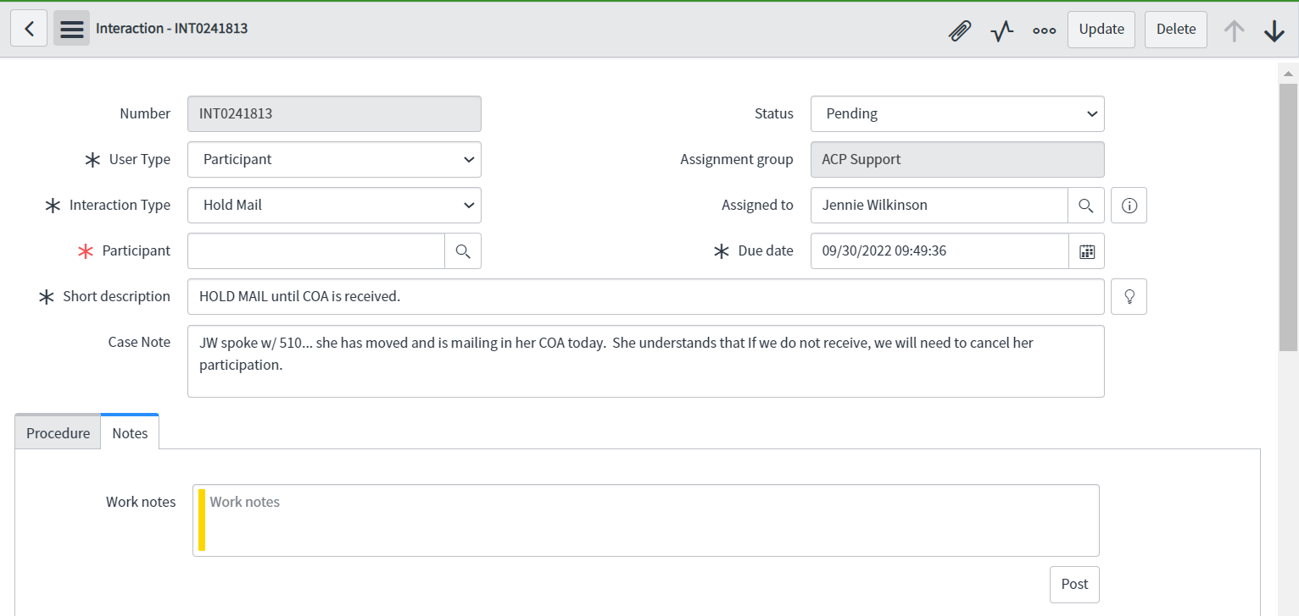

Status should read “pending” until the Hold Mail is no longer in effect and be assigned to the individual opening the interaction.

The Short description must include “HOLD MAIL”

Case Note describes the interaction between the ACP staff and the participant